AudioCloud
Design Document

Version 1.0



Group Id: S19020E3FC
Supervisor Name: Muhammad Saeed (muhammad.saeed@vu.edu.pk)

Revision History
Date (dd/mm/yyyy) | Version | Description | Author
26 June 2019 | 1.0 | This document contains different activities used in Audio Cloud platform like ERD Diagrams which is graphical representation of entities and their relationship with each other.it contains sequence diagrams, architecture design diagrams which describes layered architectural model for the system.it also contains class diagrams (classes their attributes and relationships among objects), database diagrams (describes a way to logically group objects), interface design (shows he important features of the platform) and test cases. | BC140400342  BS140401325  Group ID: S19020E3FC

Table of Contents

- Introduction of Design Document
- Entity Relationship Diagram (ERD)
- Sequence Diagrams
- Architecture Design Diagram
- Class Diagram
- Database Design
- Interface Design
- Test Cases

- Introduction of Design Document
This document is the first document for designing the “Audio Cloud” Web Application. The purpose of this document is to provide the understanding of the application’s working and how users will interact with it.

1.1 Benefits of the document.
- The design document helps to understand how system is works.
- The design process translates the requirements into a representation of the software that can be assessed for quality before coding begins.
- Design the technical kernel of the software engineering. During design, progressive refinements of the data structure, architecture, interfaces, and procedural details of software components are developed, reviewed, and documented.

1.2 Purpose of the document.
This phase starts with the requirement document delivered by the requirement phase and maps the requirements to architecture. The architecture defines the components, their interfaces and behaviors. The deliverable design document is the architecture. The design document describes a plan to implement the requirements. This phase represents the ``how'' phase. Details on computer programming languages and environments, machines, packages, application architecture, distributed architecture layering, memory size, platform, algorithms, data structures, global type definitions, interfaces, and many other engineering details are established. The design may include the usage of existing components.

  - Activities used in this Design Document:
Different activities that are used in this document are briefly explained below.

Entity Relationship Diagram (ERD):
It is graphical representation of entities and their relationship to each other.
Sequence Diagrams:
It is the most popular kind of interaction diagram. It is helpful in both when checking requirements and when checking designs.
Architecture design Diagram:
This describes the layered Architectural model for the system.
Class Diagram:
This describes the system by showing the classes, their attributes and relationships among objects etc.
Database Diagram:
This Describes a Way to logically group objects.
Interface Design:
This design shows the important features of a product.
Test Cases:
Finally test cases are provided in detail.

- Entity Relationship Diagram (ERD) (To be developed using Microsoft Visio or any other drawing software of your choice)
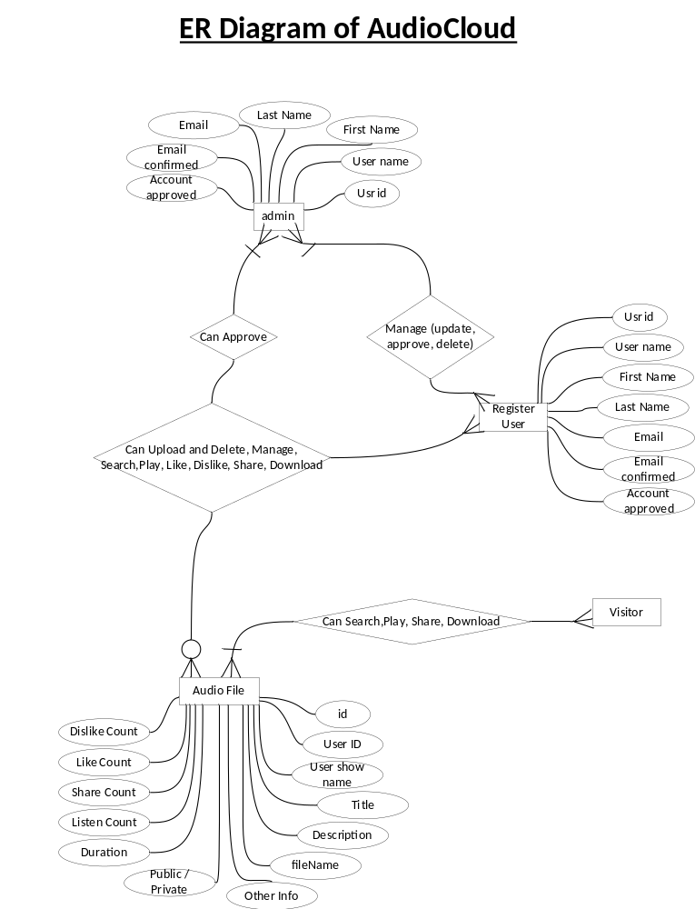
- Sequence Diagrams (To be developed using Rational Rose or any other drawing software of your choice)
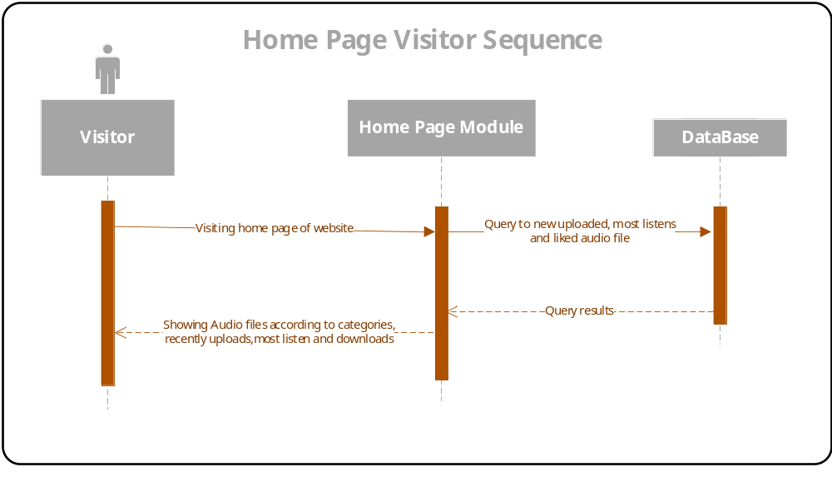
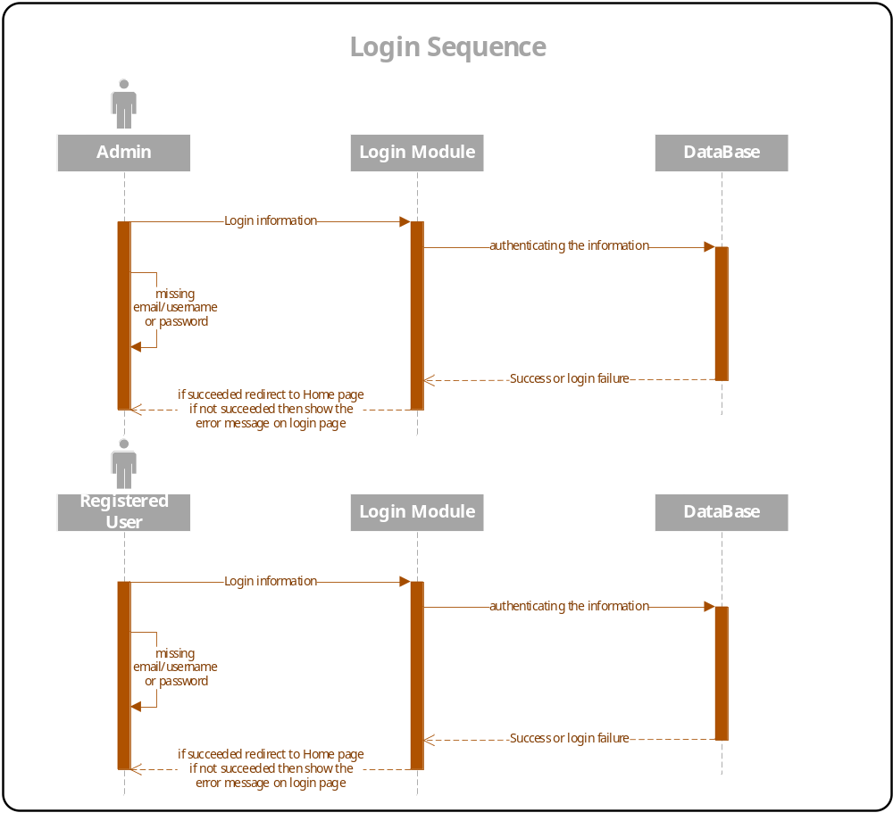
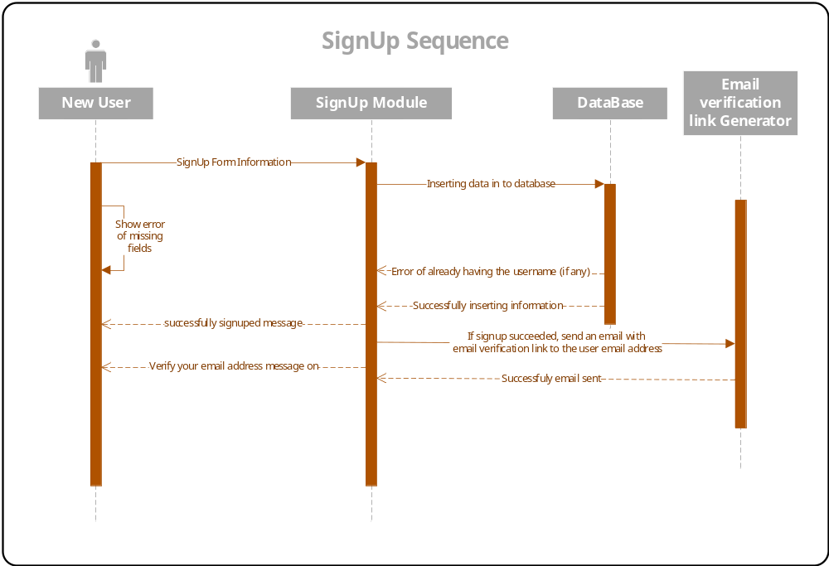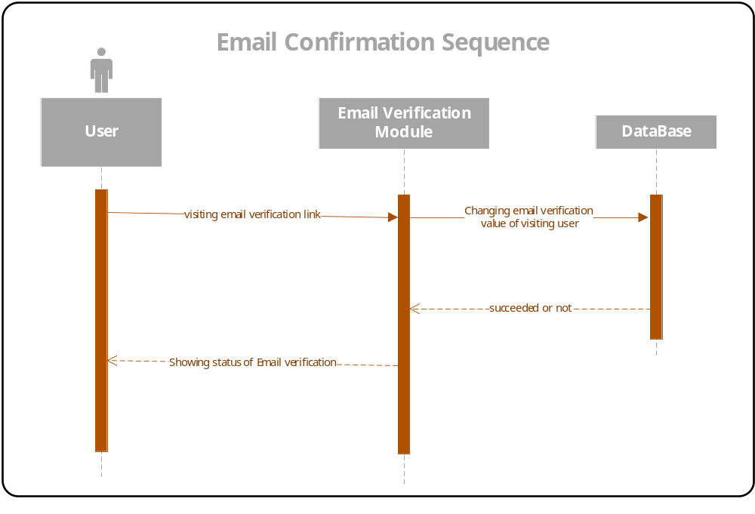
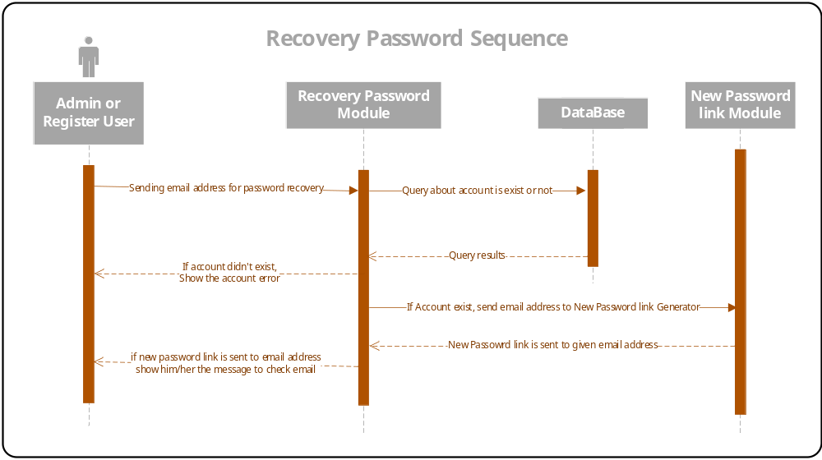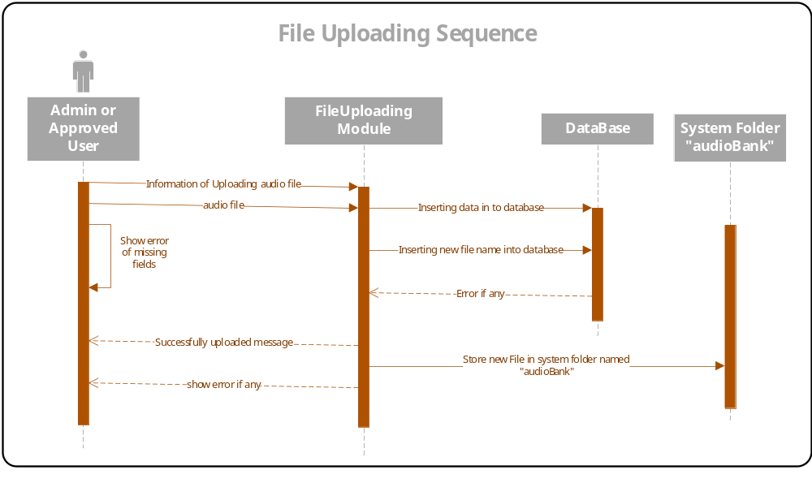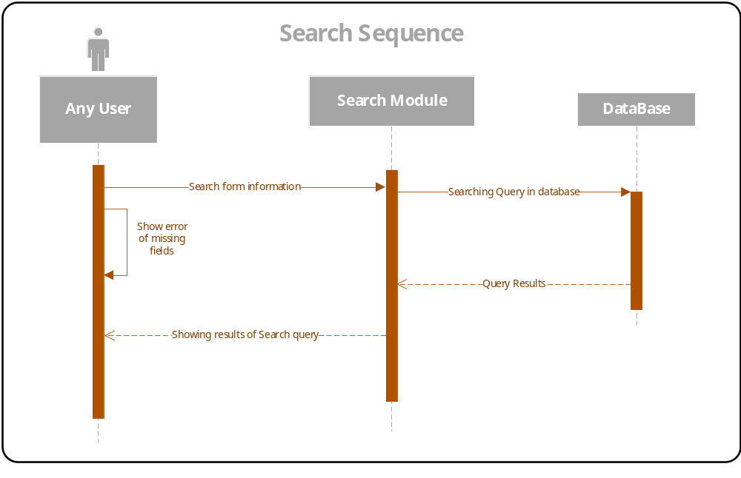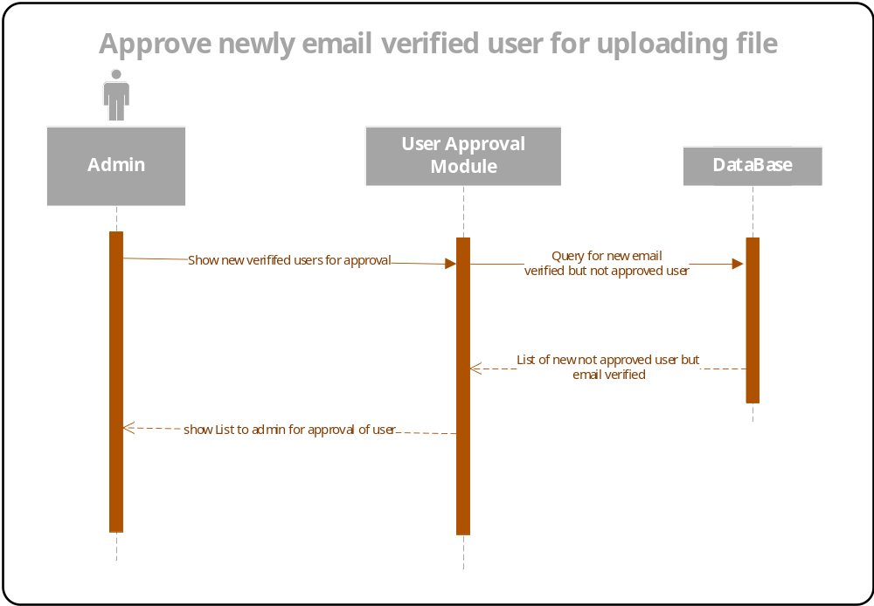
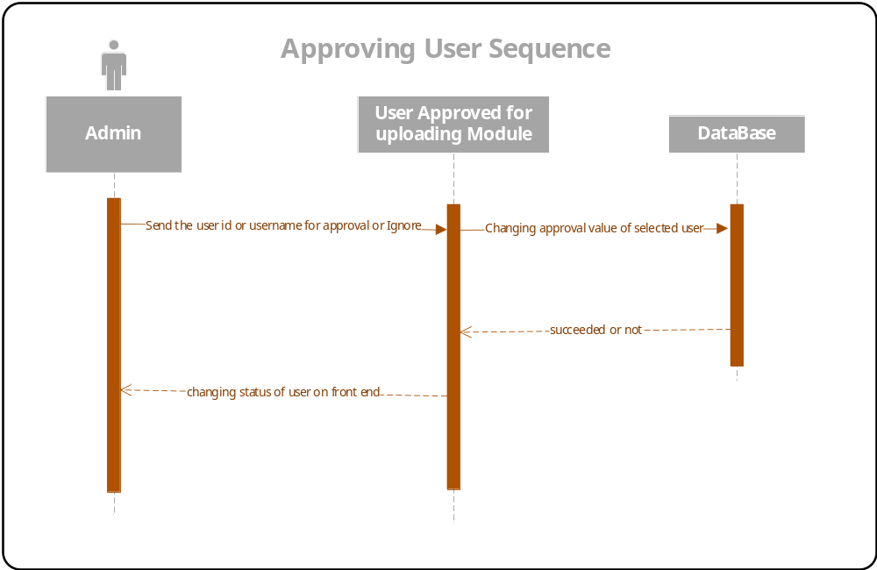
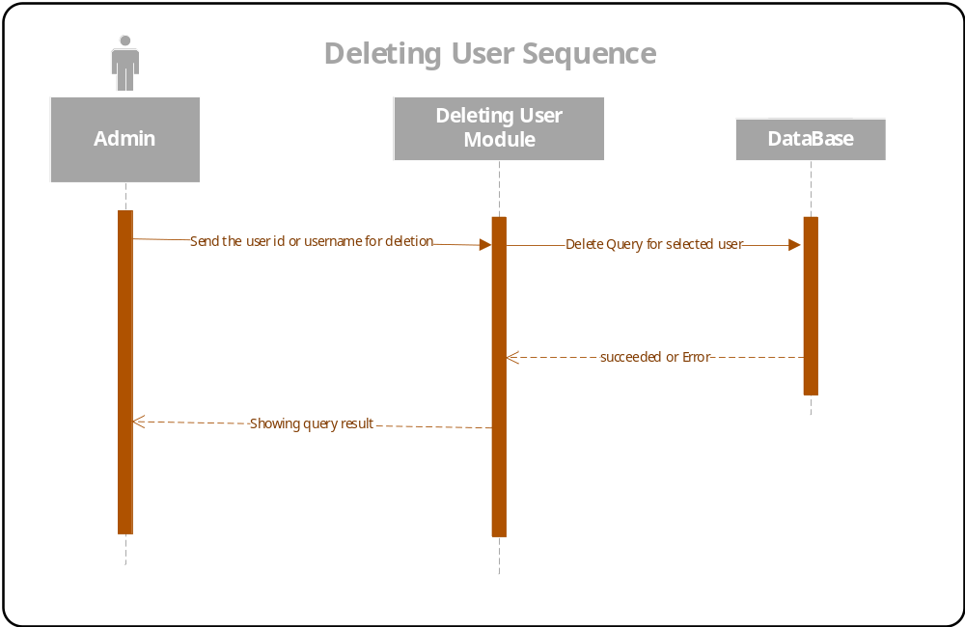
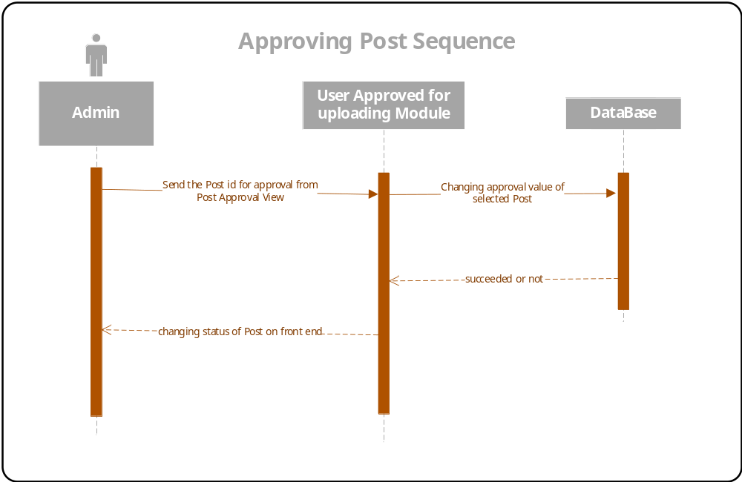
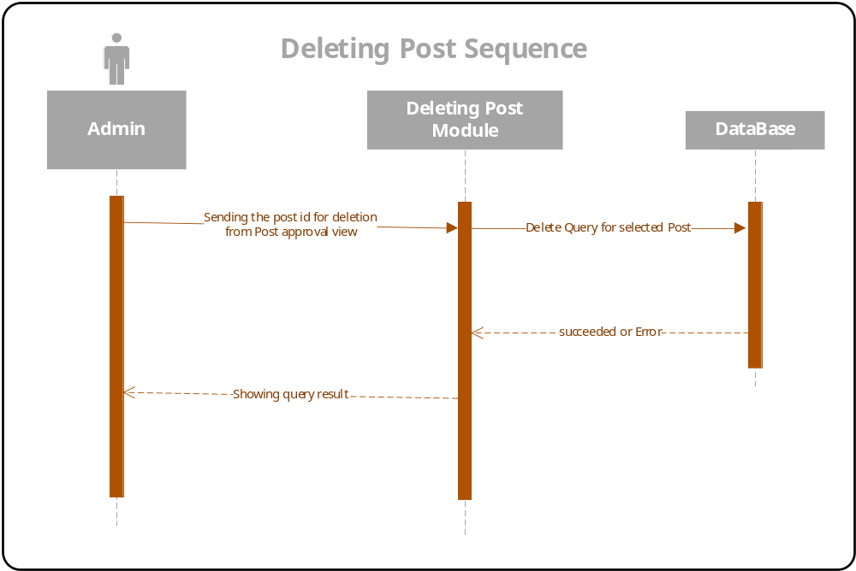
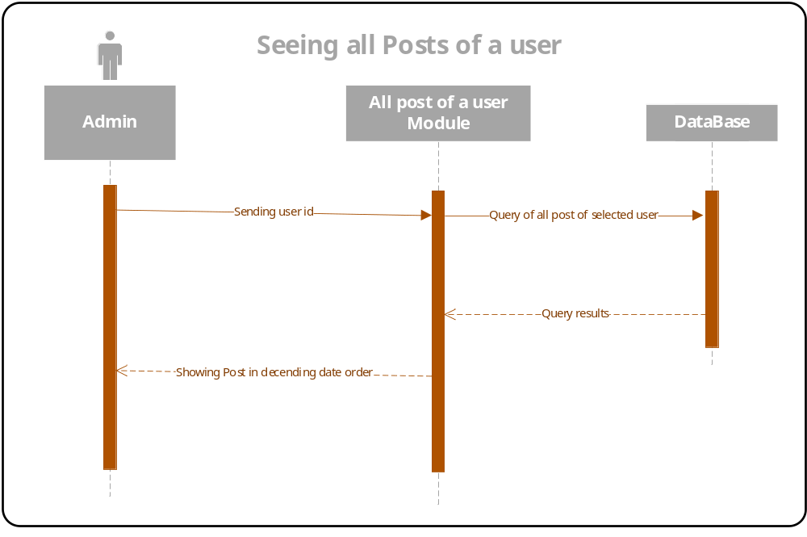
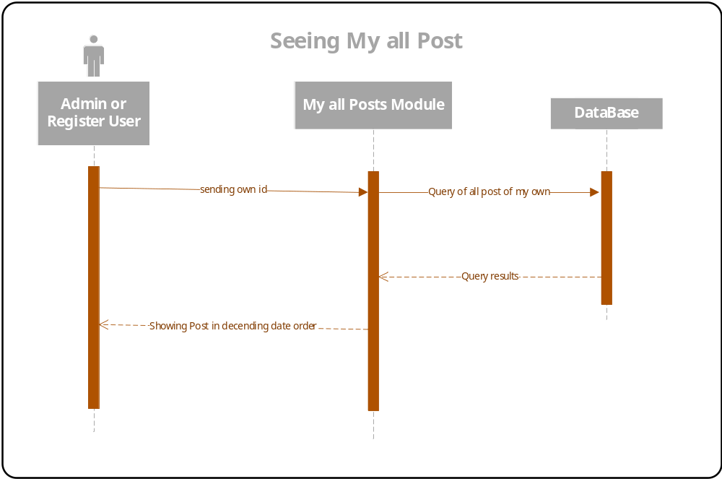

- Architecture Design Diagram
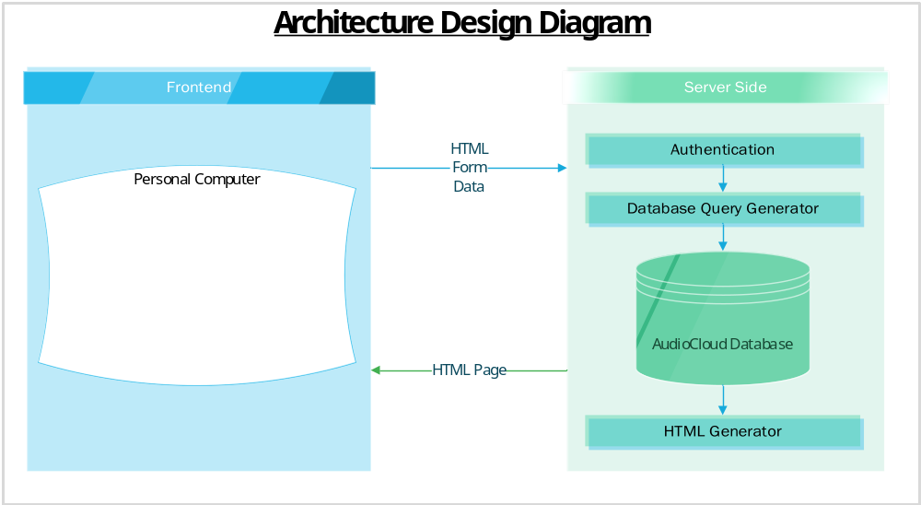

- Class Diagram

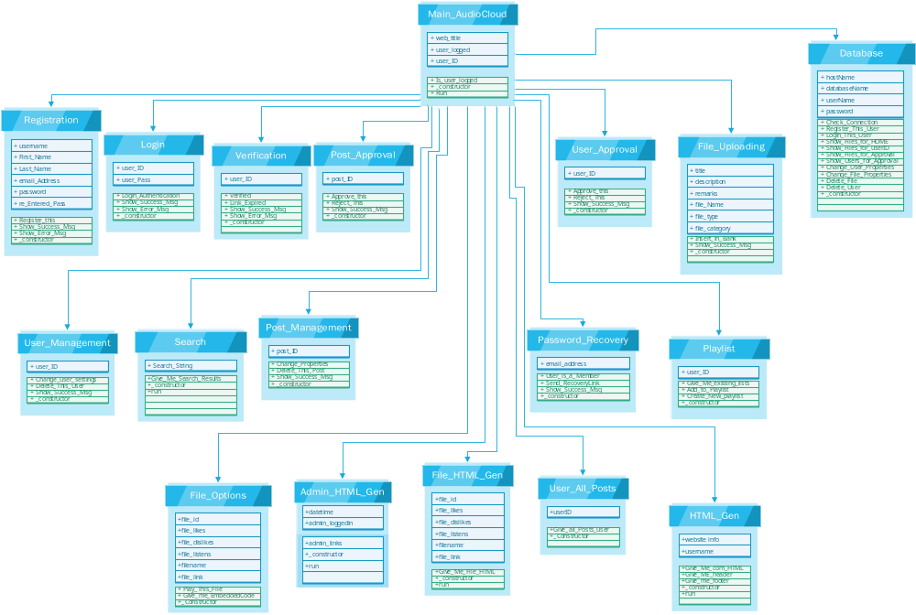

- Database Design

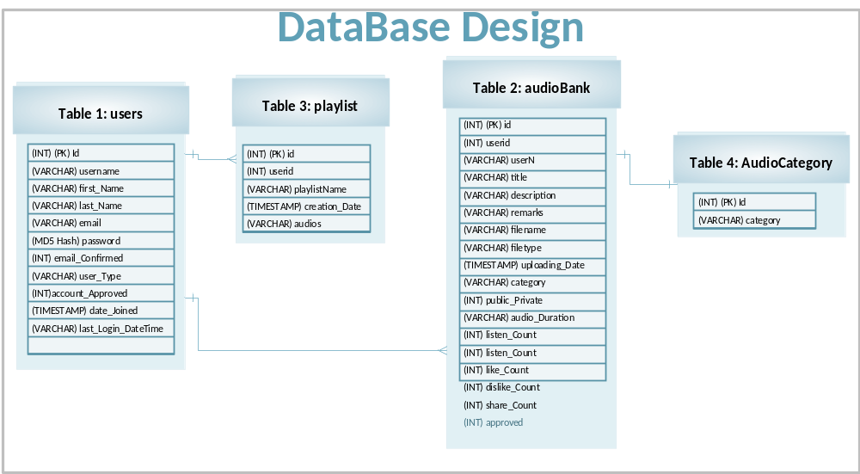

- Interface Design
Home Page Interface
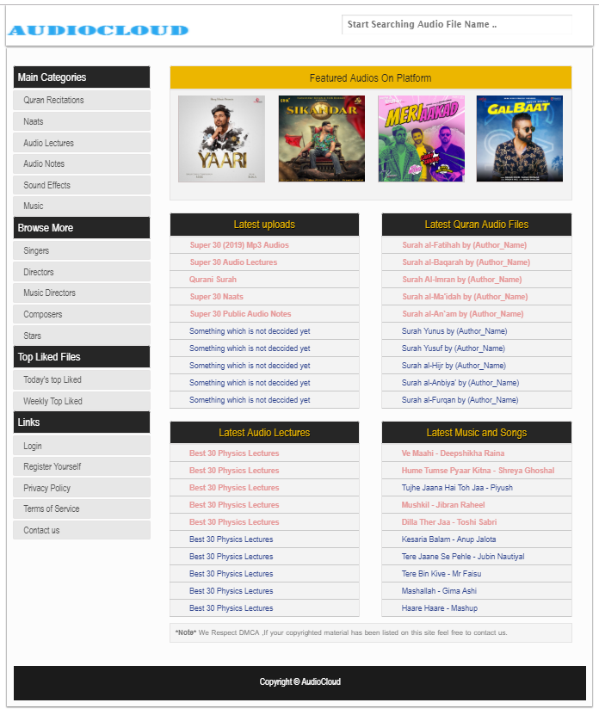
New User Registration Interface
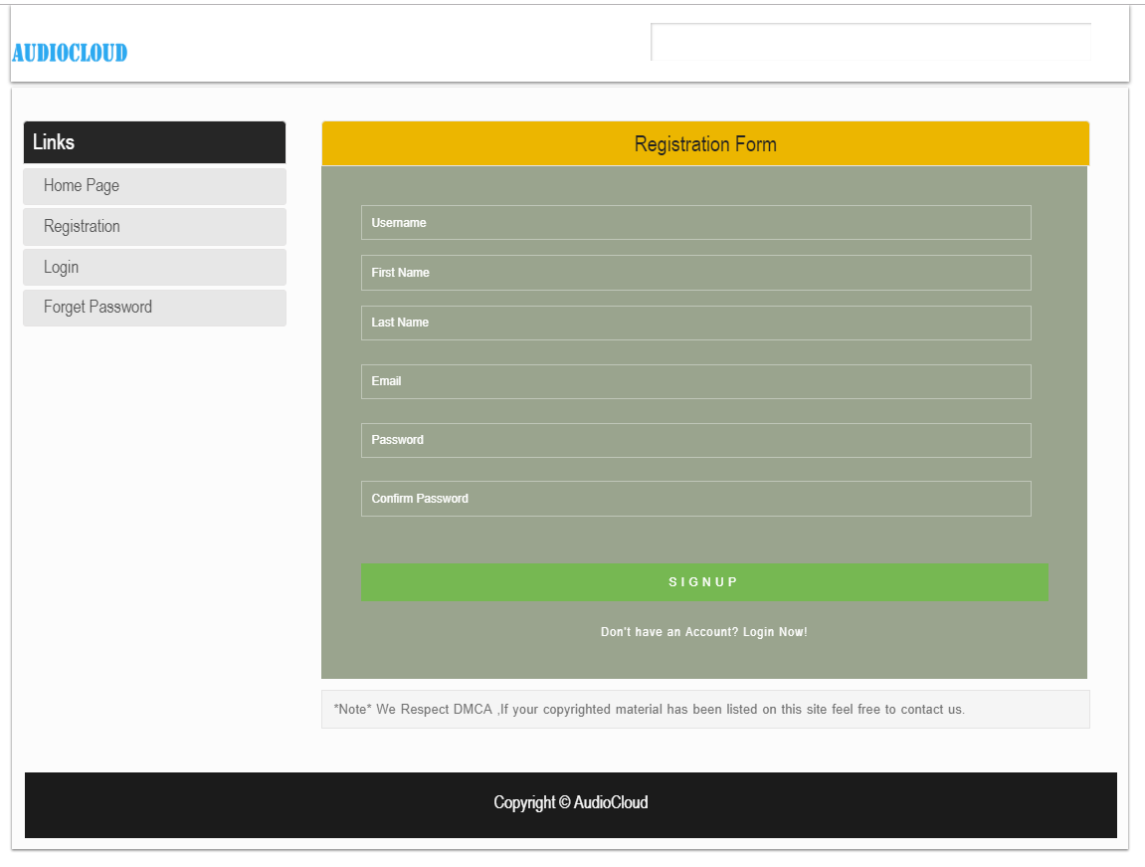

User and Admin Login Interface
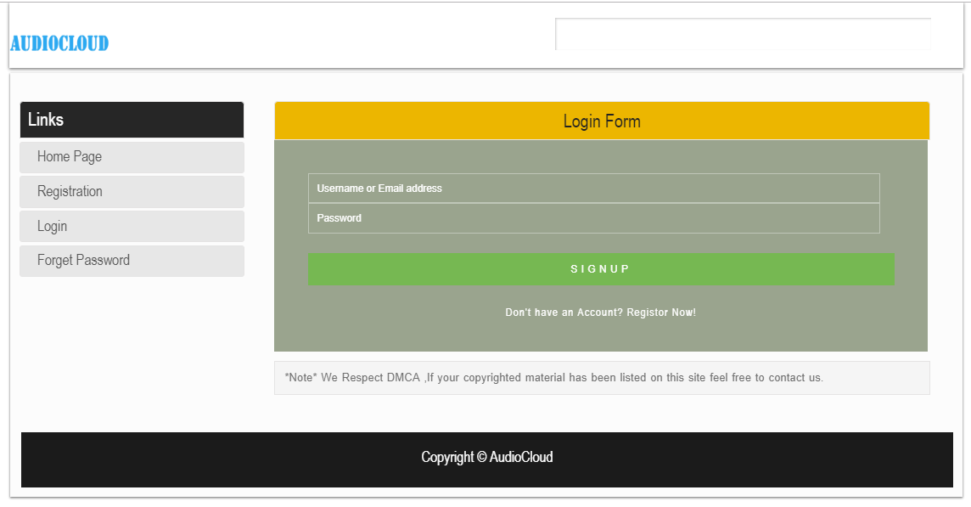

New Audio File Uploading Interface
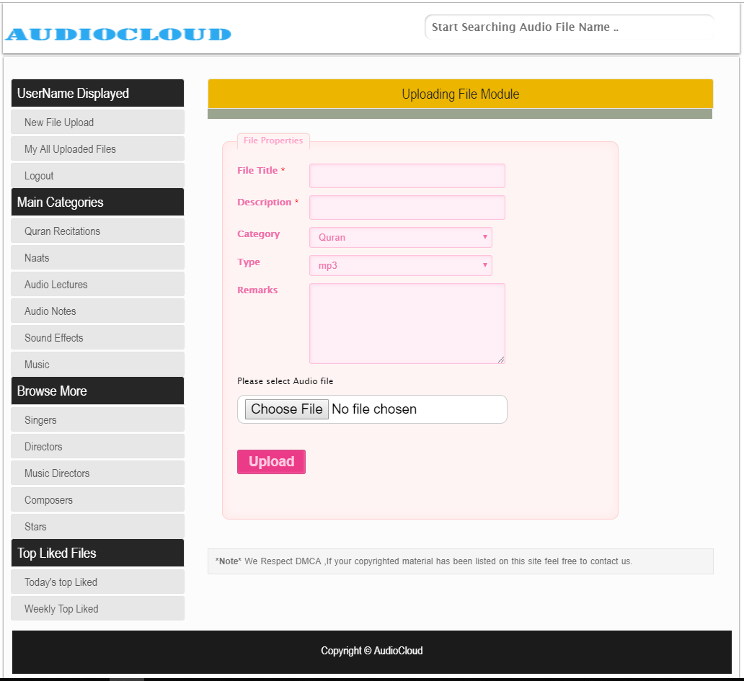

- Test Cases

  - Login Test Case
ID | Test Scenario | Test Steps | Test Data | Expected Results | Actual Results | Pass/Fail
TU01 | Checking user Login with valid Data | - Go to site login page  - Enter Username or email address  - Enter Password  Click Submit | Username = testuser  Password = pass123 | User should Login into an application | As Expected, | Pass
TU02 | Checking user Login with invalid Data | - Go to site login page  - Enter Username or email address  - Enter Password  Click Submit | Username = testuser  Password = pass321 | User should not Login into an application | As Expected, | Pass

  - Registration Test Case
ID | Test Scenario | Test Steps | Test Data | Expected Results | Actual Results | Pass/Fail
TU03 | Checking user register with valid Data | - Go to site registration page  - Enter Username  - Enter first name  - Enter last name  - Enter email address  - Enter Password  - Re-enter password  Click Submit | Username = ‘abctest’  firstName=abc  lastname = test  email = abctest@gmail.com  password = test012  password = test012 | User should register himself/herself on platform | As Expected, | Pass
TU04 | Checking user register with invalid password match | - Go to site registration page  - Enter Username  - Enter first name  - Enter last name  - Enter email address  - Enter Password  - Re-enter password  Click Submit | Username = ‘abctest’  firstName=abc  lastname = test  email = abctest@gmail.com  password = test111  password = test012 | User should not register himself/herself on platform and password didn’t match error show | As Expected, | Pass
TU05 | Checking user register without required field | - Go to site registration page  - Miss required fields  Click Submit | Some data available and some required data is not | User should not register himself/herself on platform and required field error show | As Expected, | Pass

  - Downloading Test Case
ID | Test Scenario | Test Steps | Test Data | Expected Results | Actual Results | Pass/Fail
TU06 | Checking the downloading file module is working or not | - Go to site home page  - Click on the downloading button of any audio file  Click Submit | Audio file id | File should be downloaded to the visitor/user | As Expected,  File is downloaded | Pass

  - Uploading new file test case
ID | Test Scenario | Test Steps | Test Data | Expected Results | Actual Results | Pass/Fail
TU07 | Audio File uploading with correct information | - Go to site home page  - Login to platform  - Go to uploading page  - Fill all fields and select audio file from your device  Click Submit | Audio file data and audio file | File should be uploaded to platform | As Expected,  File is uploaded | Pass
TU08 | Audio File uploading with missing required information | - Go to site home page  - Login to platform  - Go to uploading page  - Fill some fields but miss some required fields and select audio file from your device  Click Submit | Audio file data and audio file | File should not be uploaded to platform and error message show to user | As Expected, | Pass
TU09 | Uploading not an audio file | - Go to site home page  - Login to platform  - Go to uploading page  - Fill some fields but miss some required fields and select any file which is not audio file  Click Submit | file data and file | File should not be uploaded to platform and error message show to user | As Expected, | Pass

  - Search file test case
ID | Test Scenario | Test Steps | Test Data | Expected Results | Actual Results | Pass/Fail
TU10 | Checking the searching file module is working or not | - Go to site home page  - Click on the search bar type title of audio file and click search button | Audio file title | List of files is shown to the visitor / user | As Expected, | Pass

  - Online audio file play test case
ID | Test Scenario | Test Steps | Test Data | Expected Results | Actual Results | Pass/Fail
TU11 | Checking the online player is working | - Go to site home page  - Click on the play button of audio file player | Online player data | Audio file is start playing on browser | As Expected, | Pass

  - User approval test case
ID | Test Scenario | Test Steps | Test Data | Expected Results | Actual Results | Pass/Fail
TU12 | Checking the user approval is working | - Go to site home page  - Login as an admin  - Go to user approval interface  - Click on approve button of a user | User id | User approved for uploading audio file on the platform | As Expected, | Pass

  - Post approval test case
ID | Test Scenario | Test Steps | Test Data | Expected Results | Actual Results | Pass/Fail
TU13 | Checking the post approval is working | - Go to site login page  - Login as an admin  - Go to post approval interface  - Click on Approve button of a post | post id | Public Audio file is approved and shown to other website visitors | As Expected, | Pass

  - Audio file Management Test case
ID | Test Scenario | Test Steps | Test Data | Expected Results | Actual Results | Pass/Fail
TU14 | Checking file deleting process is working | - Go to site login page  - Login as an admin  - Go to audio file management interface  - Click on delete button of an audio file | Audio file id | File is deleted from the platform | As Expected, | Pass

  - User management test case
ID | Test Scenario | Test Steps | Test Data | Expected Results | Actual Results | Pass/Fail
TU15 | Checking user deleting process is working | - Go to site login page  - Login as an admin  - Go to user management interface  - Click on delete button of a user | User id | User is deleted from the platform | As Expected, | Pass

  - Seeing all post of a user test case
ID | Test Scenario | Test Steps | Test Data | Expected Results | Actual Results | Pass/Fail
TU16 | Checking seeing all post of user module is working | - Go to site login page  - Login as an admin  - Go to see all post of a user interface  - Type a user id and press see button | User id | List of posts or audio files are shown to the admin uploaded by that user | As Expected, | Pass

  - Playlist creation test case
ID | Test Scenario | Test Steps | Test Data | Expected Results | Actual Results | Pass/Fail
TU17 | Checking playlist creation is working | - Go to site login page  - Login  - Go to home page  - Click on add to playlist button and click to create new playlist | Audio file id and new playlist name | Playlist is created it new playlist button is click and audio file is added to that playlist | As Expected, | Pass
TU18 | Checking adding files to existing playlist | - Go to site login page  - Login  - Go to home page  - Click on add to playlist button and click on the name of existing playlist which user created earlier | Audio file id and existing playlist name | audio file is added to that playlist | As Expected, | Pass

  - Liking and disliking test case
ID | Test Scenario | Test Steps | Test Data | Expected Results | Actual Results | Pass/Fail
TU19 | Checking like button is working | - Go to site login page  - Login  - Go to home page  - Click on like button of a file | Audio file id | File like count is increase one time more | As Expected, | Pass
TU20 | Checking dislike button is working | - Go to site login page  - Login  - Go to home page  - Click on dislike button of a file | Audio file id | File dislike count is increase one time more | As Expected, | Pass

  - Sharing feature test case
ID | Test Scenario | Test Steps | Test Data | Expected Results | Actual Results | Pass/Fail
TU21 | Checking sharing feature is working | - Go to site login page  - Login  - Click on share button and select your desired social media | Audio fie id | File is shared on timeline of user’s social media account | As Expected, | Pass

